Bootstraping is a widely used method to find Confidence Interval for any stats like median, variance, 90th percentile etc.

This method is distribution independent, mean it does not care which distribution a given RV follows.

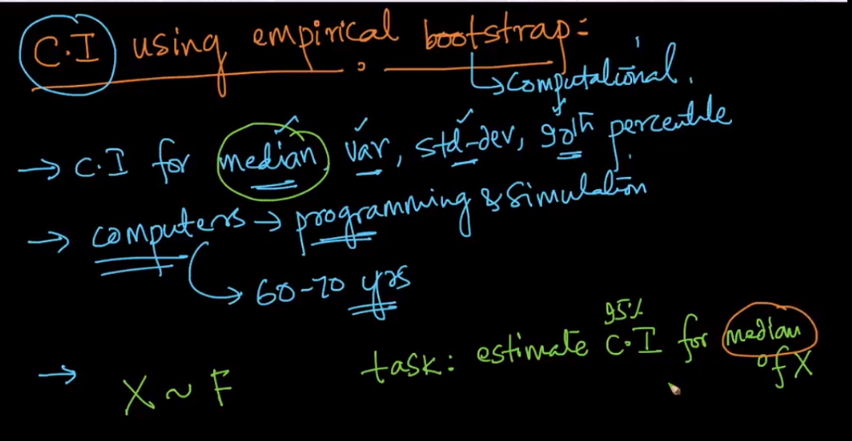

Let’s say we are given a RV **X** of size **n**, now we need to find the 95% CI for median of X. we achieve this using following steps:

1. Create samples of size **m** where m <= n, using uniform distribution.

Example: we have RV X of size 10, then we can create samples of size 10 or less than 10.

This sampling will be **sampling with repetition,** that means the observations of RV can be repeated any no times in a sample.

1. Let’s say we’ve created **K** samples from X.
2. Now we find median of each sample, that is now we have **k medians.**
3. Now we sort K medians in increasing order.
4. After sorting we just pick the 2.5th percentile and 97.5th percentile value which represent lower and upper value of CI range.

Example: If we have K=1000, that mean 1000 medians then we need to pick the middle 95% values, that is excluding initial 2.5% and last’s 2.5%, and therefore we pick 25th position and 975th position median.

**Note:** Bootstraping technique is non-parametric technique that means it does not make any assumption of the distribution of data.

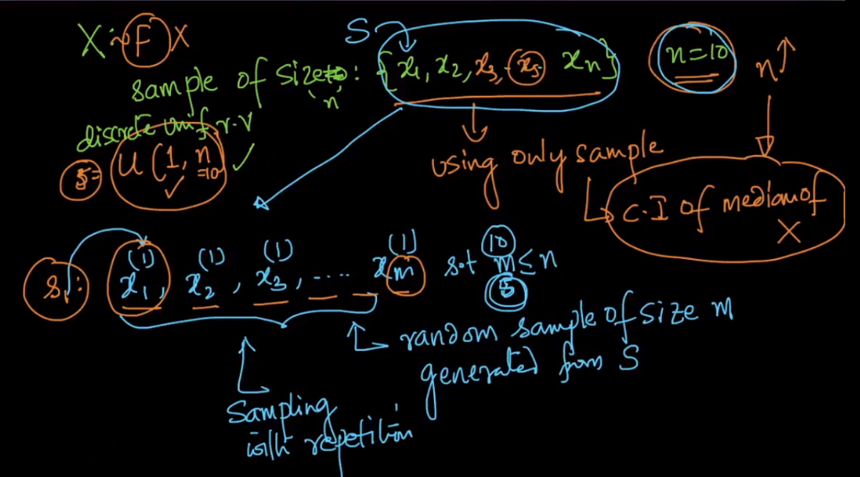

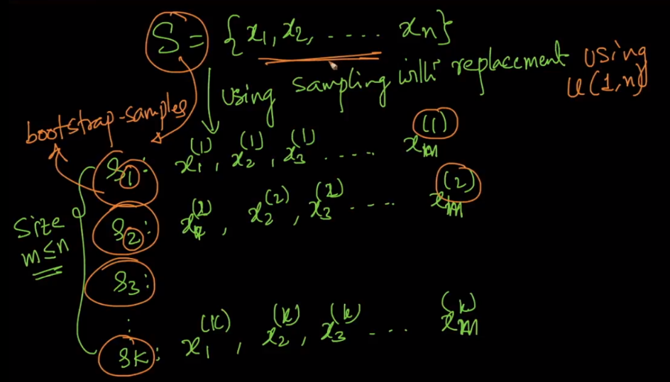

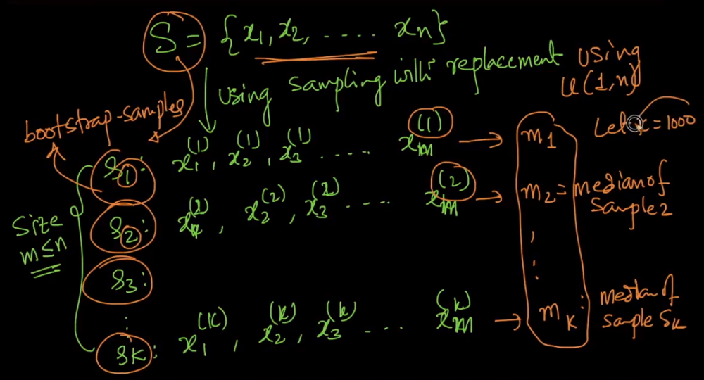

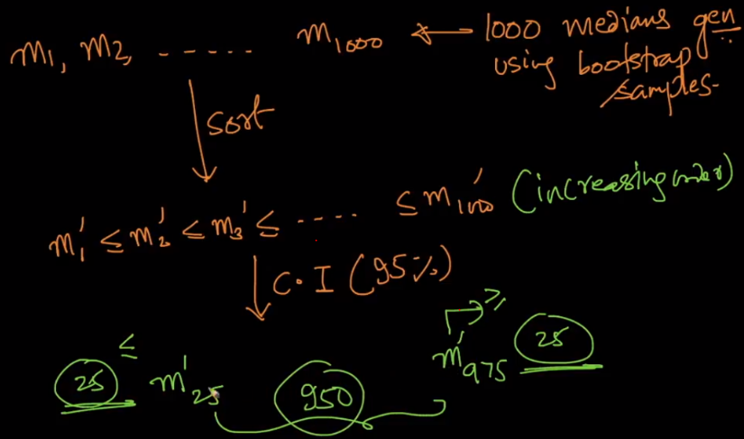



How to find CI using bootstrapping in pyton

